**Embedded Systems Professional Track**

**EgFWD - Udacity**

**On-demand Traffic**

**Light control**

Project Documentation

By:

Abdallah Salah

1.**System Description**

**It’s a traffic light with a button for the pedestrians when they want to pass the road**

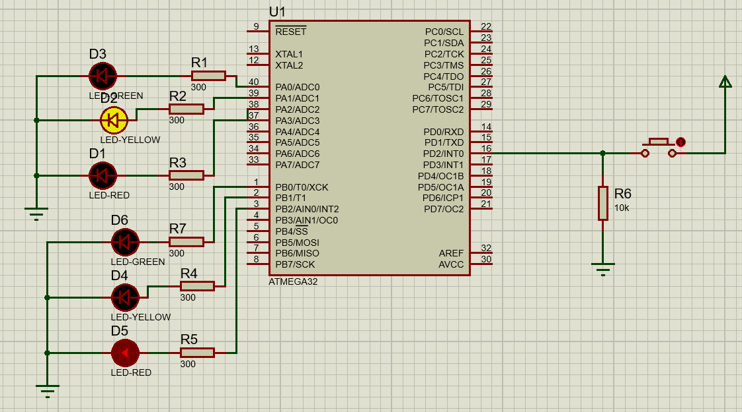

**2. System Design**

**2.1 System Requirements**

**The system consists of:**

**• AVR Atmega32 (1MHz)**

**• 2 Green LEDs**

**• 2 Yellow LEDs**

**• 2 Red LEDs**

**• 6 300 Ohm resistors**

**• 1 10k Ohm resistor**

**• 1 Push Button**

**3.Flow Chart**

